Банк заданий по функциональной грамотности по английскому языку
5-9 классы
The London zoo
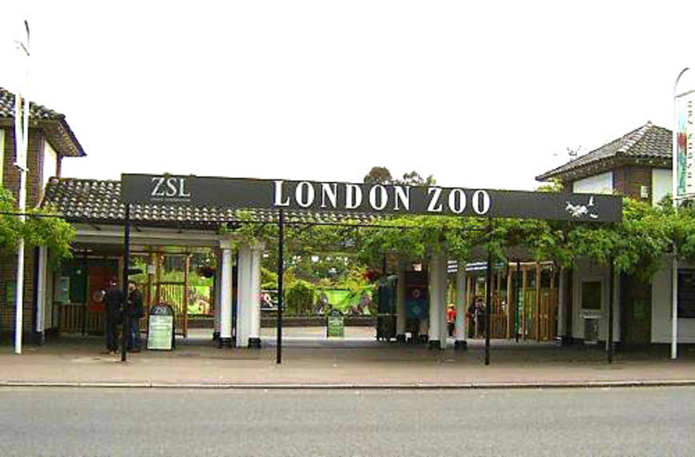

1.London is one of the most beautiful cities of Europe. You can travel East and West, but there are few places you can find only in London. Monuments and historical buildings were always attractive to me. But sometime I also like to see modern places and learn new facts about them.
2.Some places are very unique. They look really modern but in the reality they have long history. One of this places is London zoo. There is no European who has never heard about this place. It is a world’s oldest zoo. It was opened in London in 1828. In the beginning it supposed to be a collection for scientific study. And for public it was opened as a zoo in 1847. This zoo is pretty big and rich for different kind of animals, birds and fish. I guess here you can find everything.
3.Everyday hundreds of people come here and not only British people. Tickets are pretty expensive, but for European standards it’s a normal price. You can buy it for 30 pounds. Entrance for children costs less. Of course it’s important to check program and schedule in advance and maybe even to book tickets.
Task 1. Choose the titles for each part of the text. (3 балл) . Подберите заголовки к каждой части текста .
- The price of visit
- Everyone knows this place
- About London
Task 2. Read the text and say if the statements TRUE (T), FALSE (F) or NOT STATED (NS). Прочитайте текст и отметьте предложения (5 баллов)
1. London Zoo is in New York.
2. You can see some unique places in London.
3. There are a lot of bird and animals in the Zoo.
4. London Zoo was opened in London in 1835.
5. The London Zoo is located in north part of London.
Task 3. Put the sentences in the correct order. Поставьте предложения в правильном порядке в соответствии с текстом. (5 балл)
- It was opened a long time ago.
- Hundreds of people come here from different counties.
- You can learn a lot of facts about London
- There are a lot of monuments and beautiful buildings .
- One of the most interesting places of London is London Zoo.
Task 4. Find English equivalents to the words. Найдите в тексте следующие слова, запишите их. (10 баллов)
- Уникальный
- Тысячи людей
- Исторические здания
- Богатый
- Различные виды животных

Task 5. Read the fact file and match the information on the next page. Прочти и Соотнеси информацию (12 баллов)
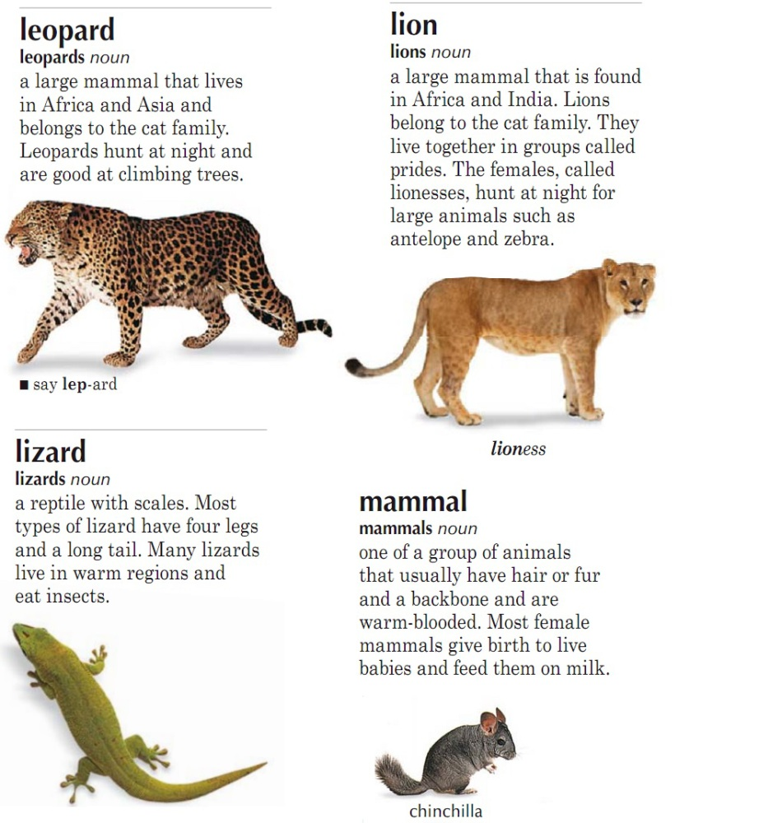

Name of the animal | Climbing trees
Home | Antelope , zebra , insects
Food | Four legs, long tail
Body | Lizard, mammal, lion
It can | Group of lions are called pride
Fun fact | Africa, Asia

Task 7. Read the text again and circle the most interesting and new information . Прочитайте текст и выпишите наиболее интересную и новую информацию (3 балла) Читательская грамотность
Task 8. Write a fact file about an animal. На основе прочитанной информации составьте рассказ о животном (5 баллов)
What kinds of animal is this?
What country does it live in?
What kinds of food does it eat?
What is the appearance of the animal?
What can it do?

Ответы
Максимум 43 балла.
Task 1.
1.C
2.B
3.A
Task 2 .
1.F
2.T
3.T
4.F
5.NS
Task 3 . 3,4,5,1,2.
Task 4.
- Уникальный – unique
- Тысячи людей – hundreds of people
- Исторические здания – historical buildings
- Богатый- rich
- Различные виды животных- different kinds of animals
Task 5.

Name of the animal | Lizard, mammal, lion
Home | Africa, Asia
Food | Antelope , zebra , insects
Body | Four legs, long tail
It can | Climbing trees
Fun fact | Group of lions are called pride

«Buckingham Palace».
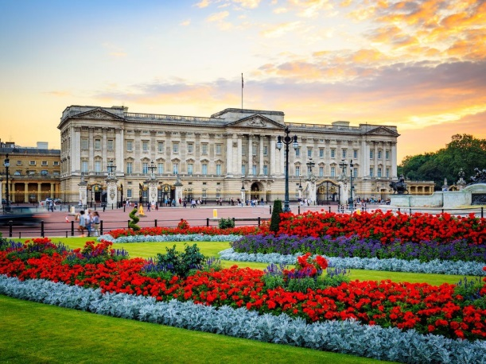
Текст: Buckingham Palace has served as the official London residence of the UK’s sovereigns since 1837 and today is the administrative headquarters of the Monarch. Despite being the place where many official events are held, the State Rooms at Buckingham Palace are also open to visitors every summer.
The Queen and the Royal Family stay at the Palace on weekdays. They have rooms on the first floor of the north wing. When the Queen is staying the Royal Standard flag is flown above the central balcony. The Queen has an office where she usually works. Prince Charles has his own office and library there.
However before becoming the administrative headquarters of the Monarch Buckingham House was bought by George III in 1761 for his wife. It was used as a family house and almost all George III’s children were born there. The court functions at that time were held in St.James Palace that was situated close to Buckingham House.
George IV, the son of George III, decided to reconstruct the House and transform it into a palace. John Nash selected as an architect retained the main block but added a new suite of rooms. Those rooms are now known as State and semi-State Rooms and they remain unchanged since Nash’s time.
Today Buсkingham Palace is a working building where official meetings, royal events and different ceremonies take place. Each year the Palace is visited by more than 50.000 people who come to the State banquets, lunches and dinners.
Задания к тексту:
1) Прочитай текст. Подчеркни понятия, которые характеризуют «Buckingham Palace».
2) Составь кластер характеристик «Buckingham Palace».
3) Выпиши наиболее важную информацию из текста.
4) Выбери правильный ответ, в соответствии с текстом:
1. Buckingham Palace has served as the official London residence of the UK’s sovereigns
a)since 1837
b) since 1841
2. George IV decided to reconstruct the House and transform it into
a) a palace
b) a museum
3. House was bought by George III in 1761 for
a) his wife
b) his sister
5) Ответь на вопросы :
1. What events are held at Buckingham Palace?
2.Does the Queen have her own office ?

